Wordpress

Businesses are looking for a good and engaging websites to showcase their potential and for the marketing purposes. The rapidly growing new and creative businesses in the market demand quick and best solutions for them. In the digital global ecosystem, you can get the best and quick website solution using WordPress technology.

Work Review of WordPress Projects

MarkTeck

# Summary

This website is created for a client where I was responsible to change the theme of the project and the structure of the content for the website. The website consists of Home, Services, About and Contact Page. It is fairly simple and the best part is that it has an envato theme applied to it. The user can contact the client using the contact form or also visiting the referral links like of Facebook, Twitter etc. The website describes the business and the services that are offered to the clients. The theme conveys a good and mature ecosystem to the user that visits the website.

## **Home**

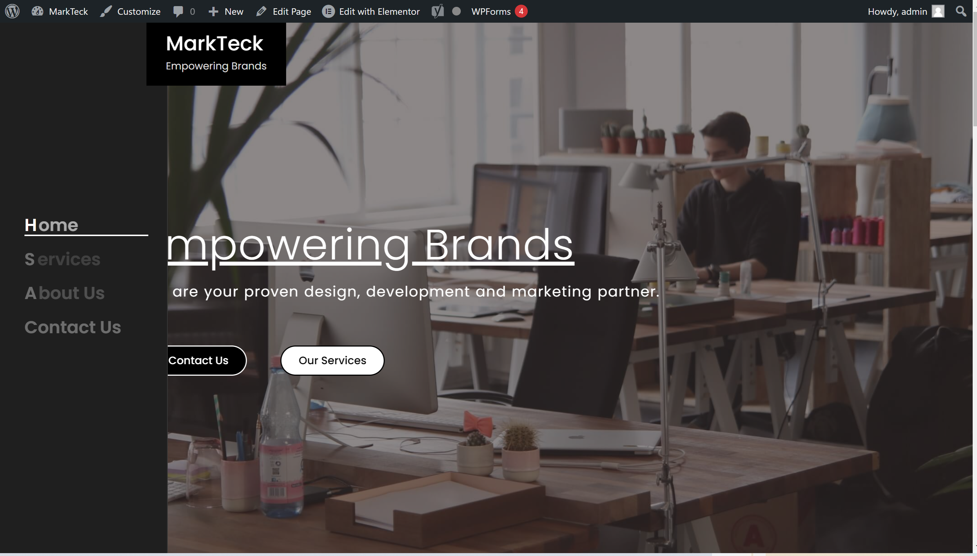

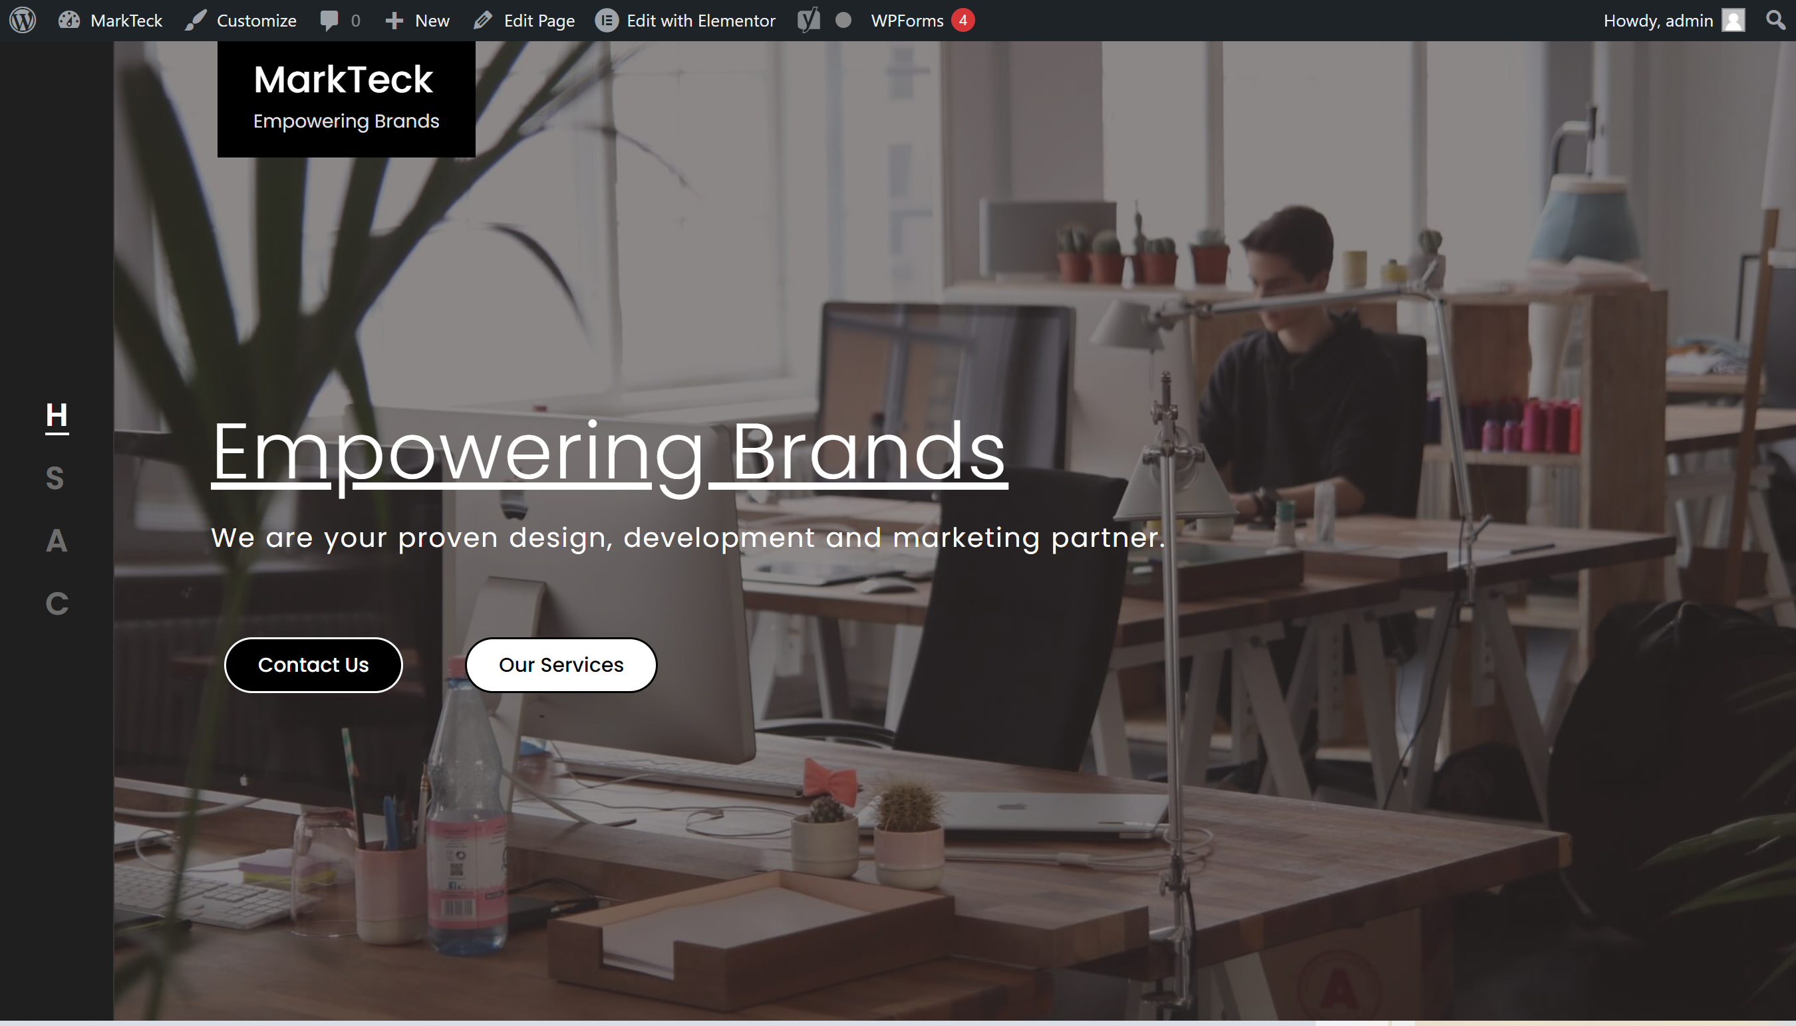

## **Services**



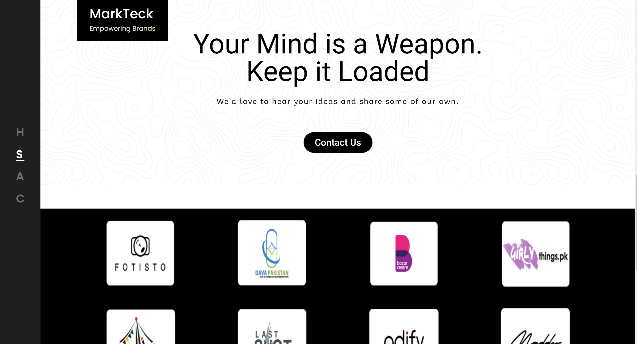

## **About Us**

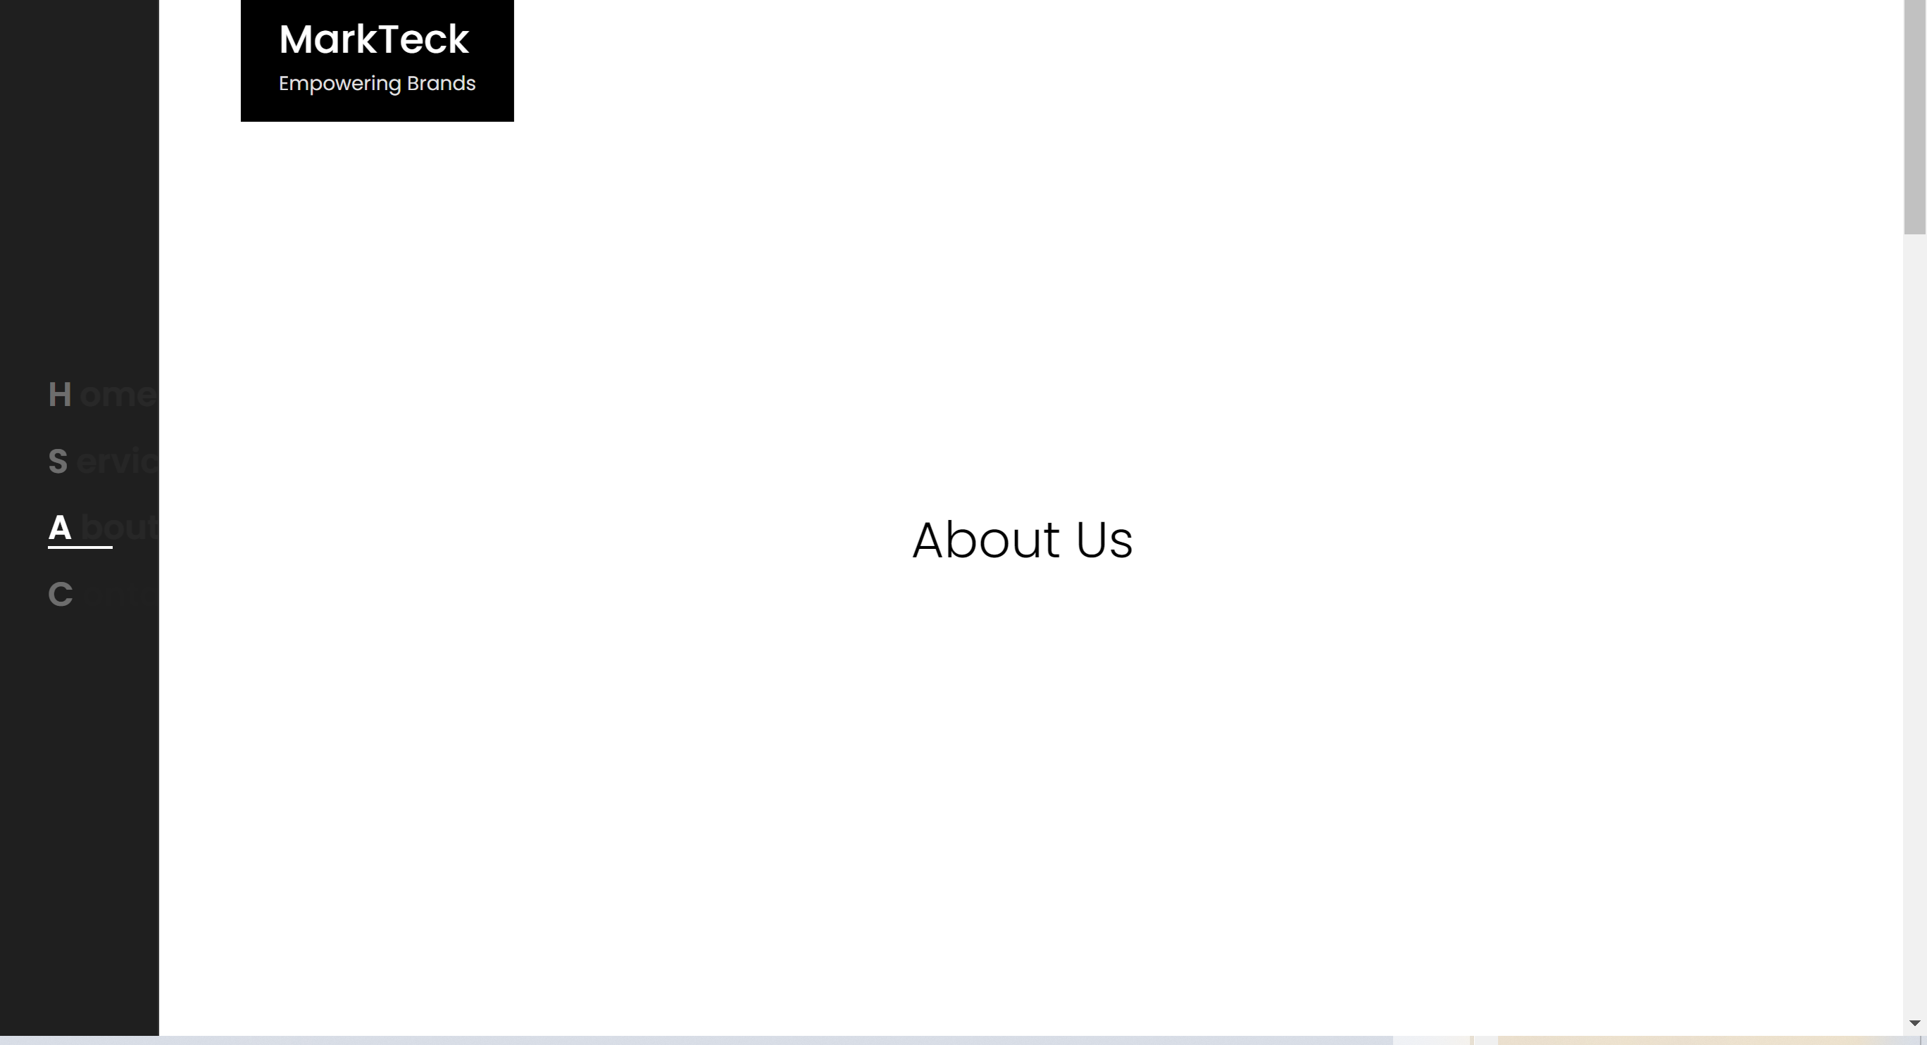

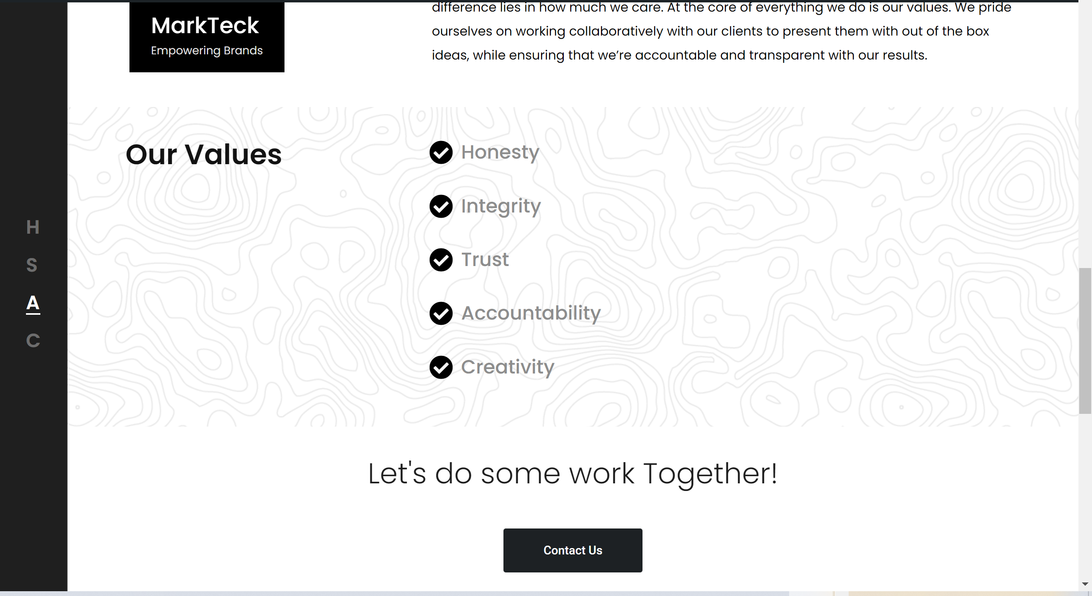

## Contact Us

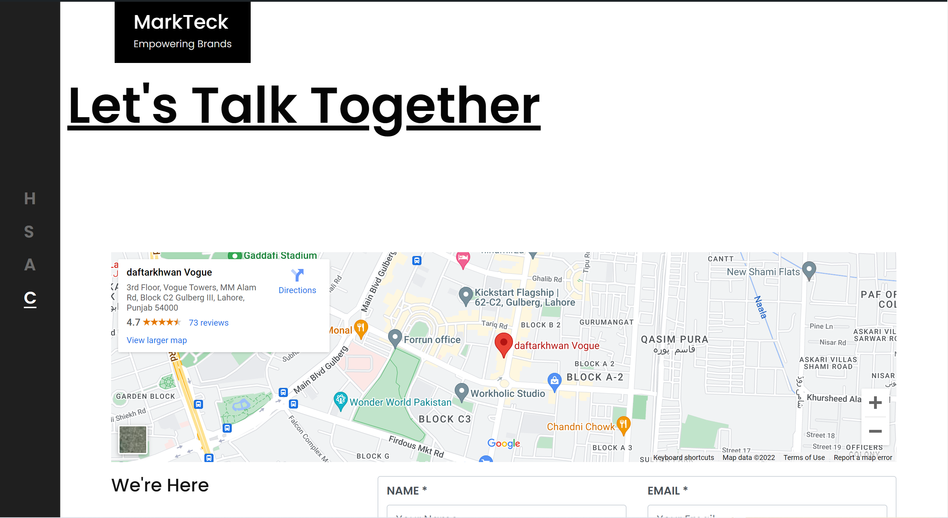

**Please visit the website to see it in more detail:**

[**https://markteck.com/**](https://markteck.com/)

MyDoctorOnline

# Summary

This website was created as a part of the coursera project. It is a medical website that has a BetterHealth theme implemented on it. The website is designed for a digital customer interaction to the information and to the system of the hospital. Our aim is to connect the patients in the town to the clinic of Dr. Rafi, who is a best doctor in our town.

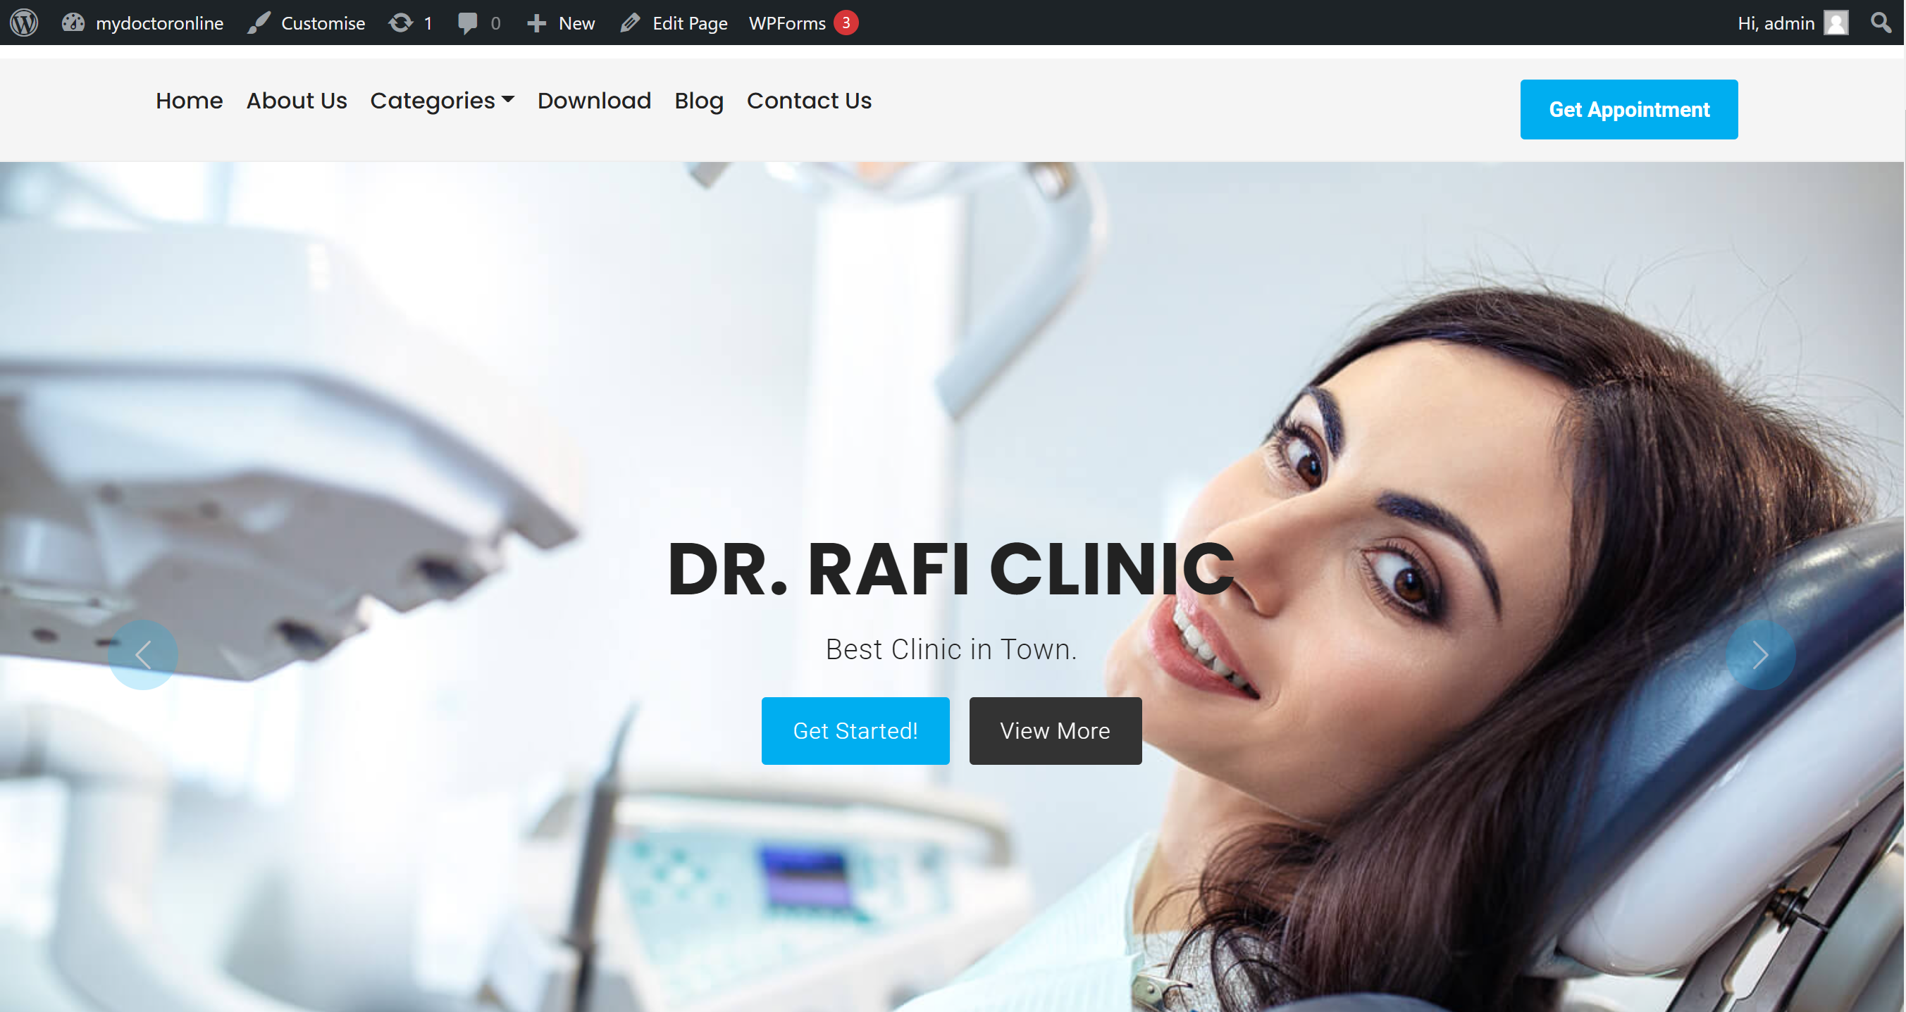

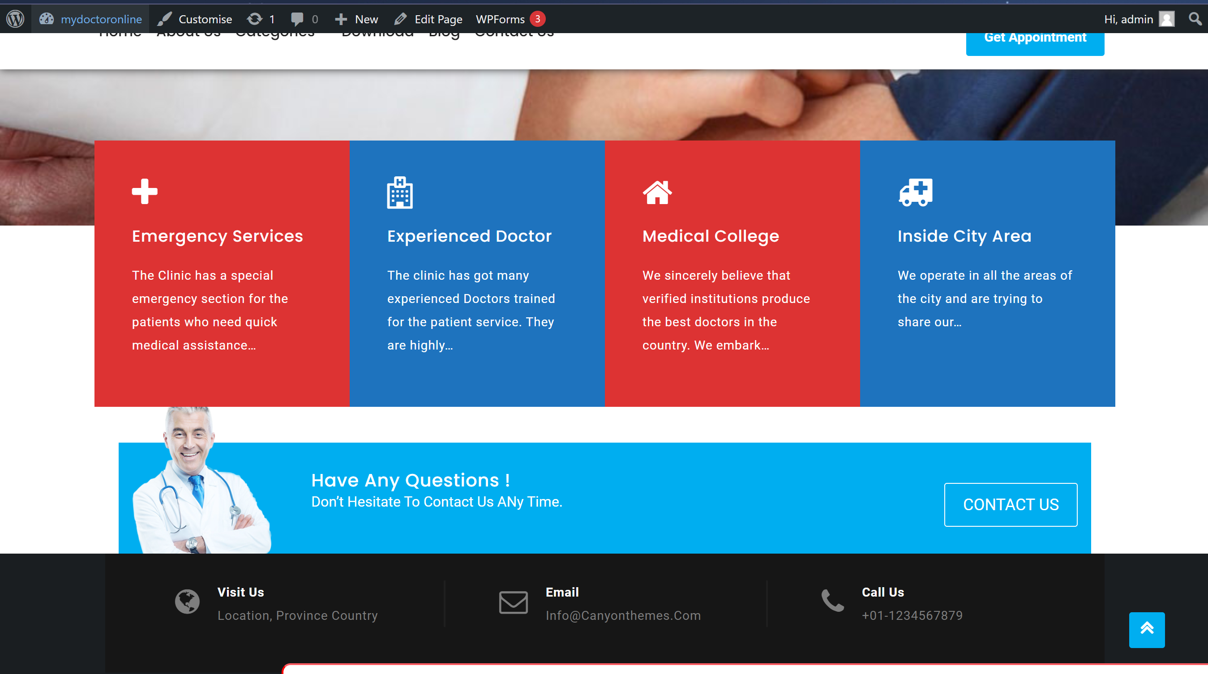

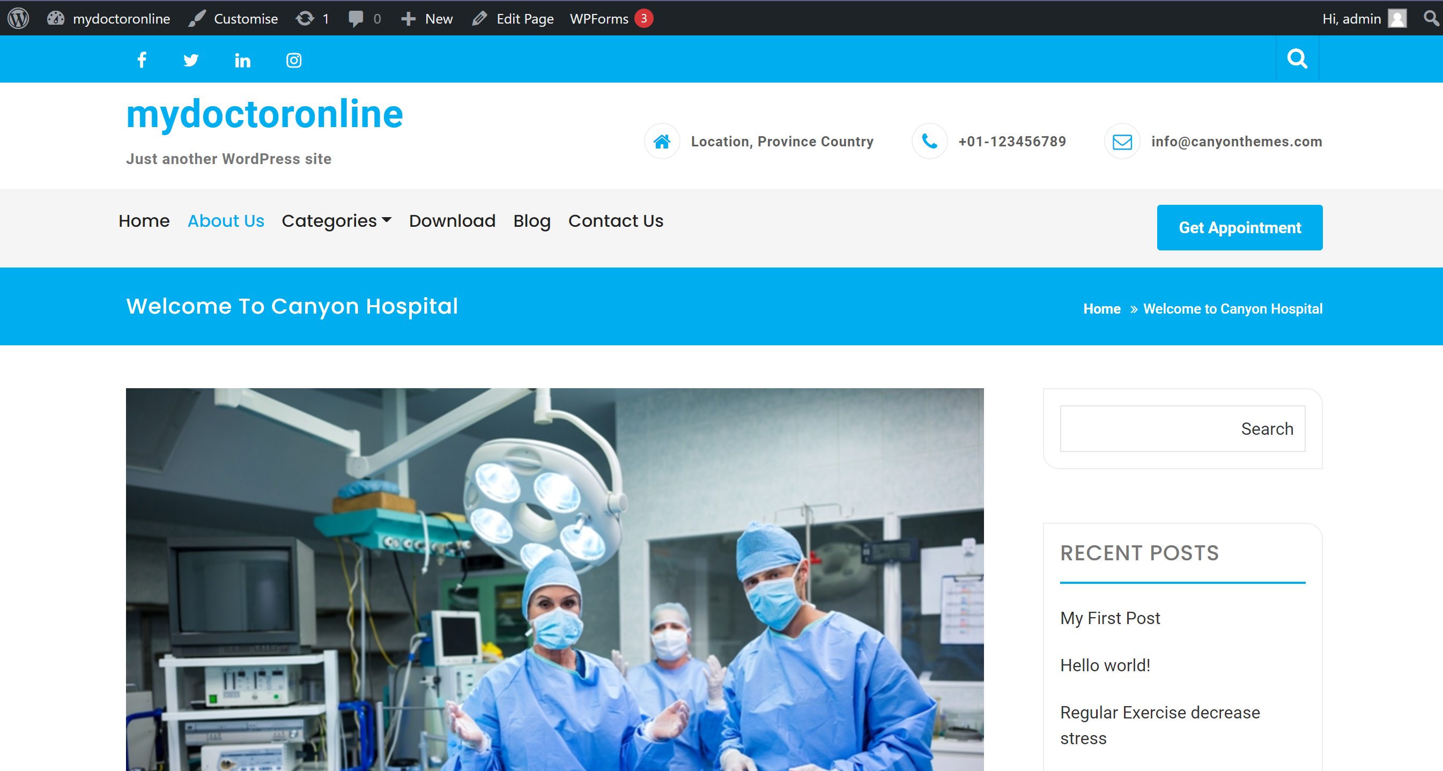

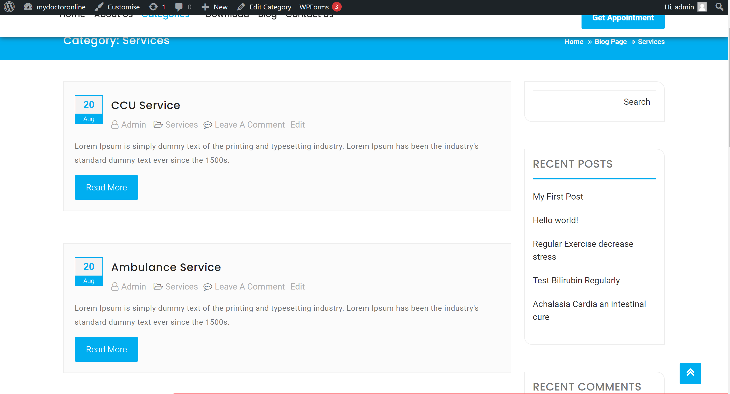

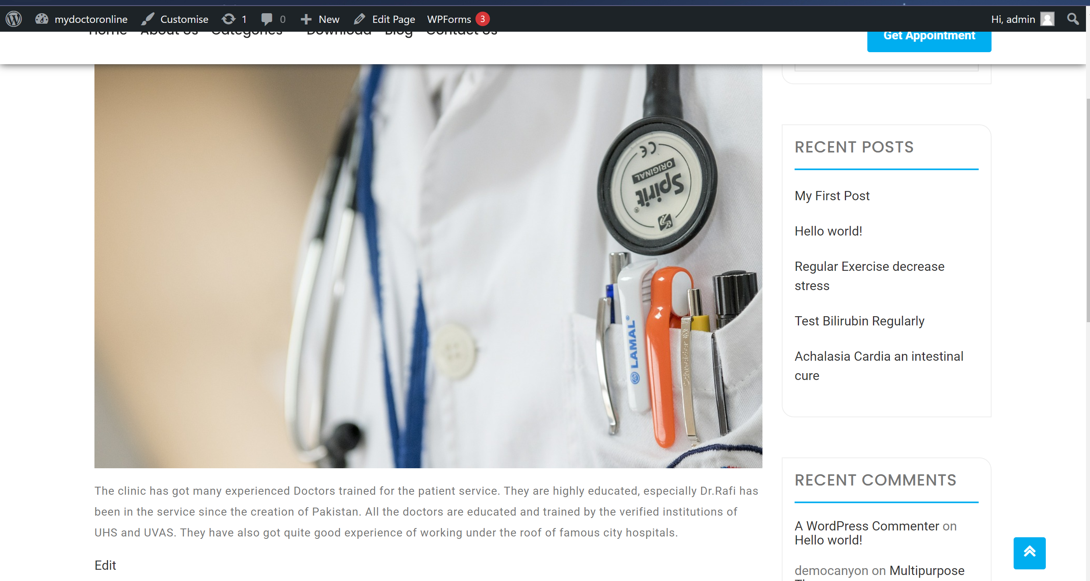

**Please explore the beauty of this sample website**

[**https://mydoctoronline.000webhostapp.com/**](https://mydoctoronline.000webhostapp.com/)